1. List all townhouses sold in the suburb *Annandale* in *2016*

SELECT S.pid

FROM SHAREDPROPERTY AS S, PROPERTY AS P, SHAREDLISTING AS L

WHERE proptype = 'townhouse' AND S.pid = P.pid AND suburb = 'Annandale' AND S.pid = L.pid AND S.unitno = L.unitno AND dateclose LIKE '2016%' AND L.type = 'sell'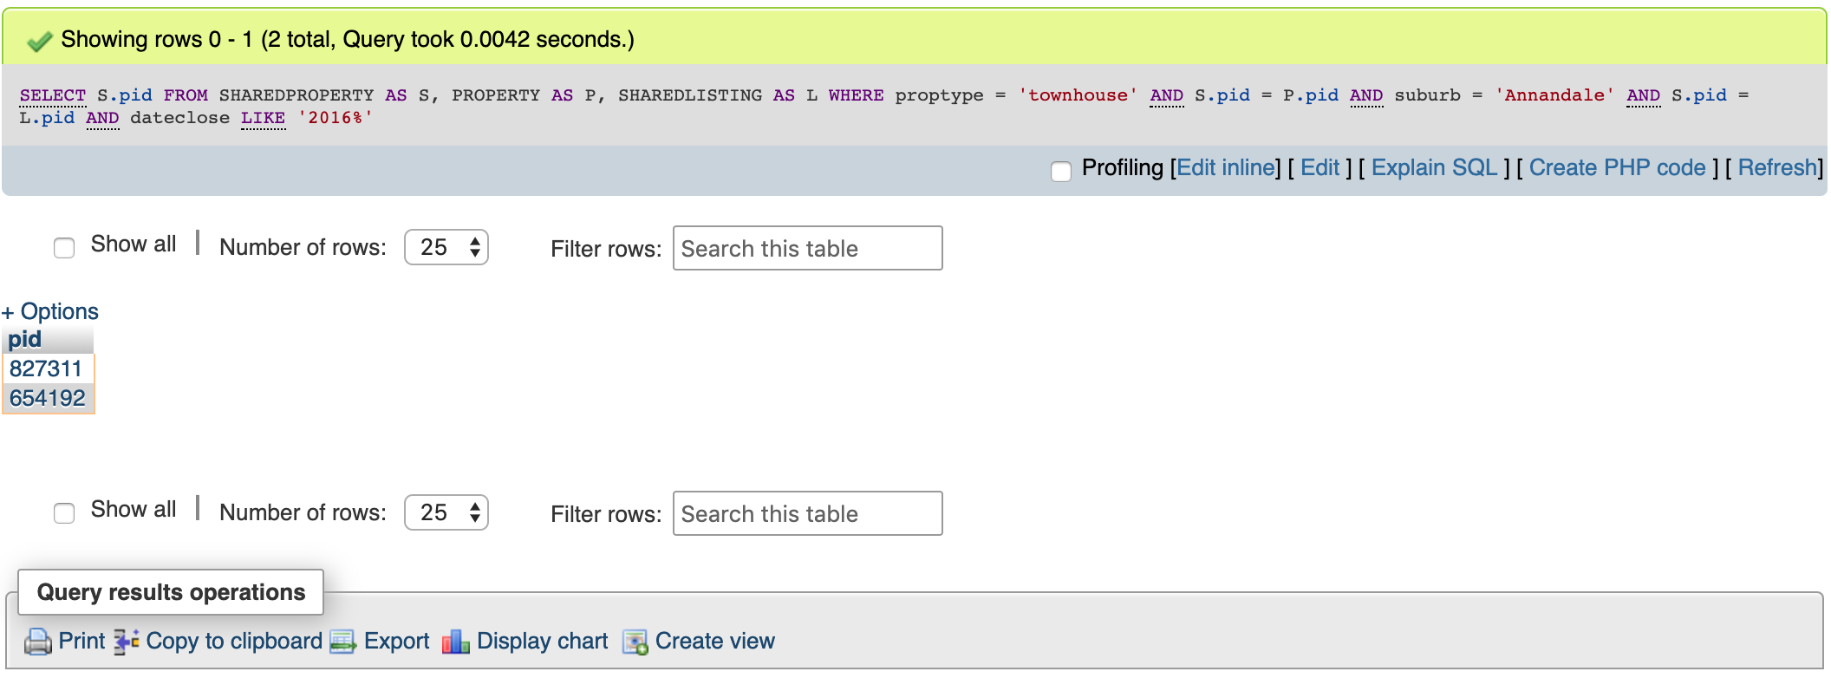

2. Find the suburbs that have not had any sales since *2017*

SELECT DISTINCT P.suburb

FROM PROPERTY AS P , LISTING AS L, SHAREDPROPERTY AS SP, SHAREDLISTING AS SL

WHERE P.pid = L.pid AND L.type = 'sell' AND P.suburb NOT IN (

SELECT A.suburb

FROM PROPERTY AS A, LISTING AS B

WHERE A.pid = B.pid AND B.type = 'sell' AND dateclose IN (

SELECT dateclose

FROM LISTING

GROUP BY dateclose

HAVING dateclose > '2017-01-01'))

OR SL.pid = SP.pid AND SL.unitno = SP.unitno AND SP.pid = P.pid AND SL.type = 'sell' AND P.suburb NOT IN (

SELECT C.suburb

FROM PROPERTY AS C, SHAREDPROPERTY AS D, SHAREDLISTING AS E

WHERE E.pid = D.pid AND E.unitno = D.unitno AND D.pid = C.pid AND E.type = 'sell' AND dateclose IN (

SELECT dateclose

FROM SHAREDLISTING

GROUP BY dateclose

HAVING dateclose > '2017-01-01'))

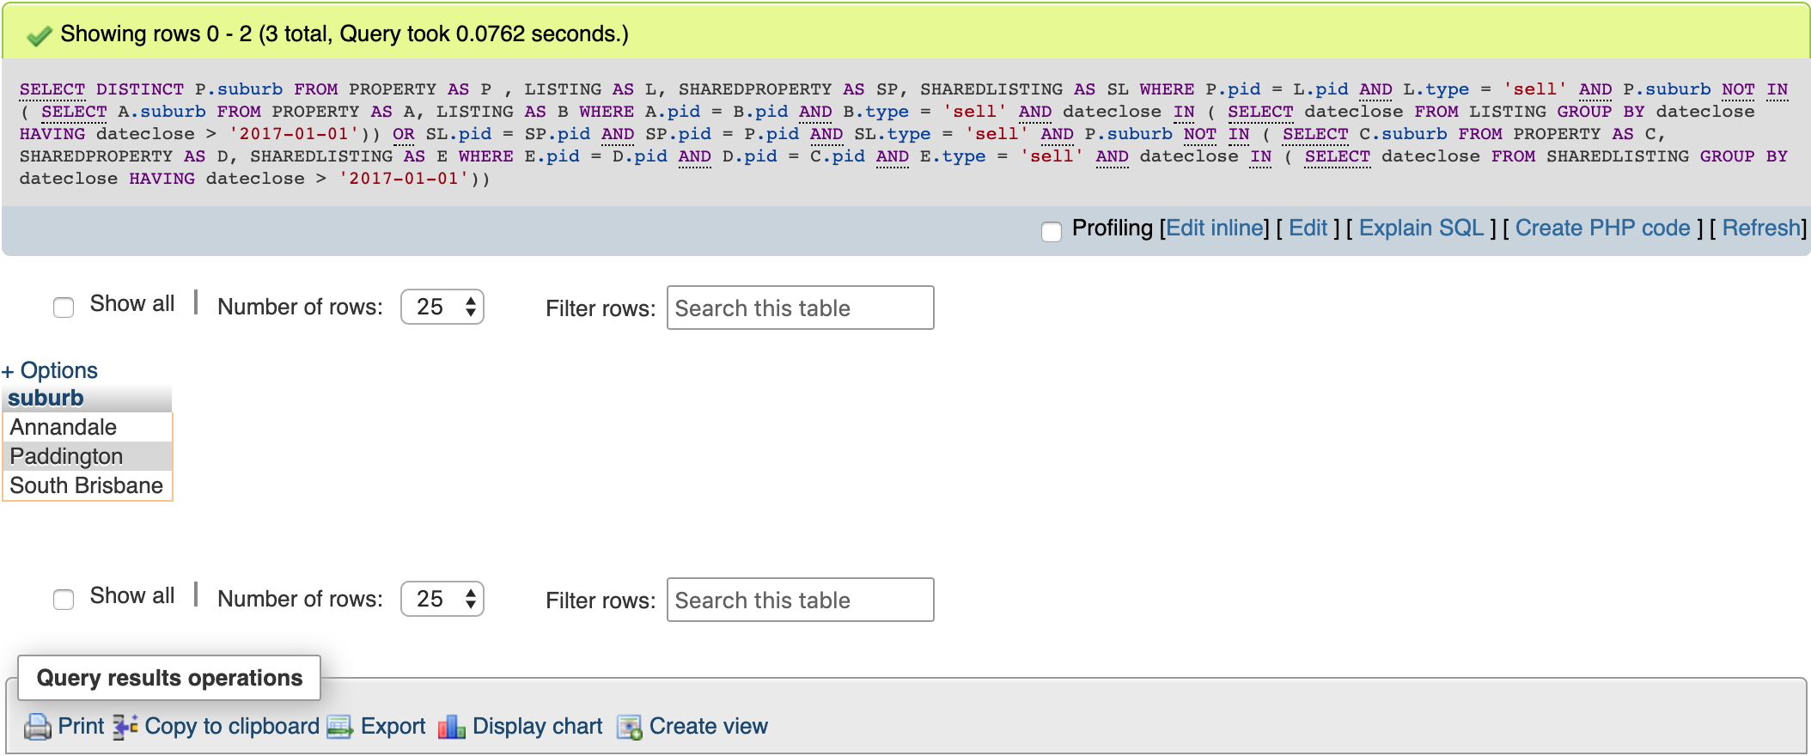

3. Find the total number of apartments available for rent on *Parramatta Road*

SELECT COUNT(*)

FROM SHAREDPROPERTY AS SP, PROPERTY AS P, SHAREDLISTING AS SL

WHERE SP.proptype = 'apartment'

AND P.pid = SP.pid AND P.stname = 'Parramatta' AND P.sttype = 'Road'

AND SL.pid = SP.pid AND SL.unitno = SP.unitno AND SL.type = 'rent'

AND SL.dateclose IS NULL

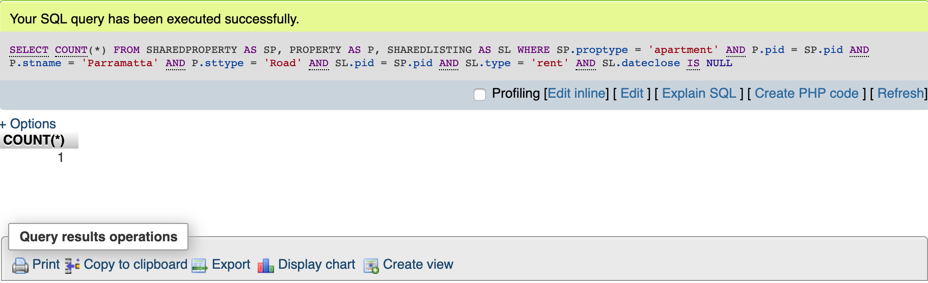

4. Which street in the suburb Camperdown has the highest average rent

SELECT P.stname, P.sttype

FROM PROPERTY AS P

RIGHT JOIN(

SELECT pid,price

FROM(SELECT pid,price

FROM LISTING

WHERE type = 'rent'

UNION ALL

SELECT pid,price

FROM SHAREDLISTING

WHERE type = 'rent')PE) AS PE

ON P.pid = PE.pid

WHERE P.suburb = 'Camperdown'

GROUP BY P.stname, P.sttype

ORDER BY AVG(PE.price)

DESC LIMIT 1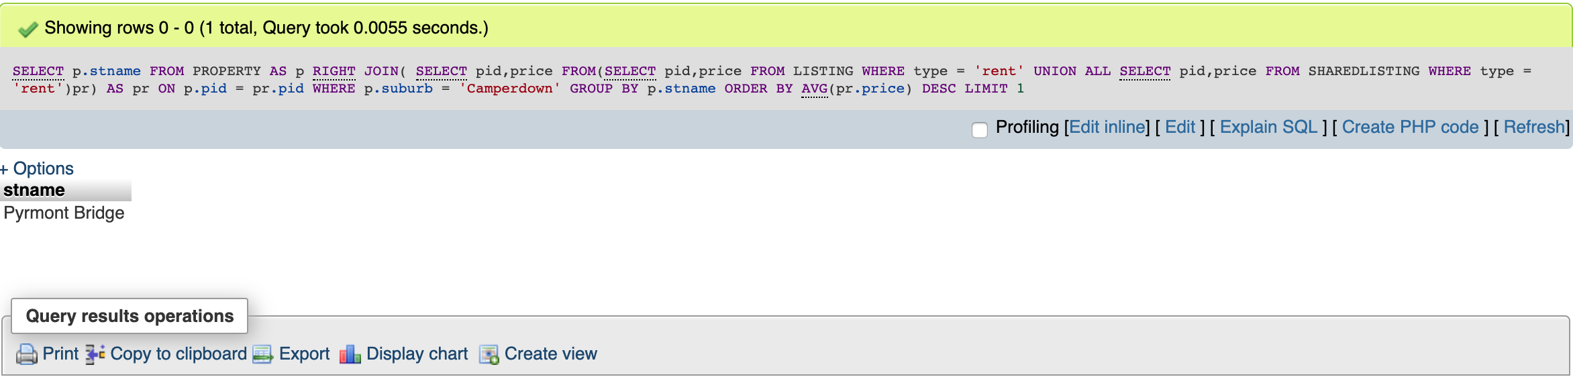

5. What is the total value of properties sold by Poh Ling from Trusted Real Estate since 2014

SELECT SUM(price)

FROM(SELECT L.price

FROM LISTING AS L, AGENT AS A, AGENCY AS Y

WHERE Y.agencylicense = A.agency AND L.agent = A.agentlicense AND L.dateclose >= '2014-01-01' AND L.type = 'sell' AND A.name = 'Poh Ling' AND Y.agencyname = 'Trusted Real Estate'

UNION ALL(

SELECT SL.price

FROM SHAREDLISTING AS SL, AGENT AS B, AGENCY AS C

WHERE C.agencylicense = B.agency AND SL.agent = B.agentlicense AND SL.dateclose >= '2014-01-01' AND SL.type = 'sell' AND <B.name> = 'Poh Ling' AND C.agencyname = 'Trusted Real Estate'))A

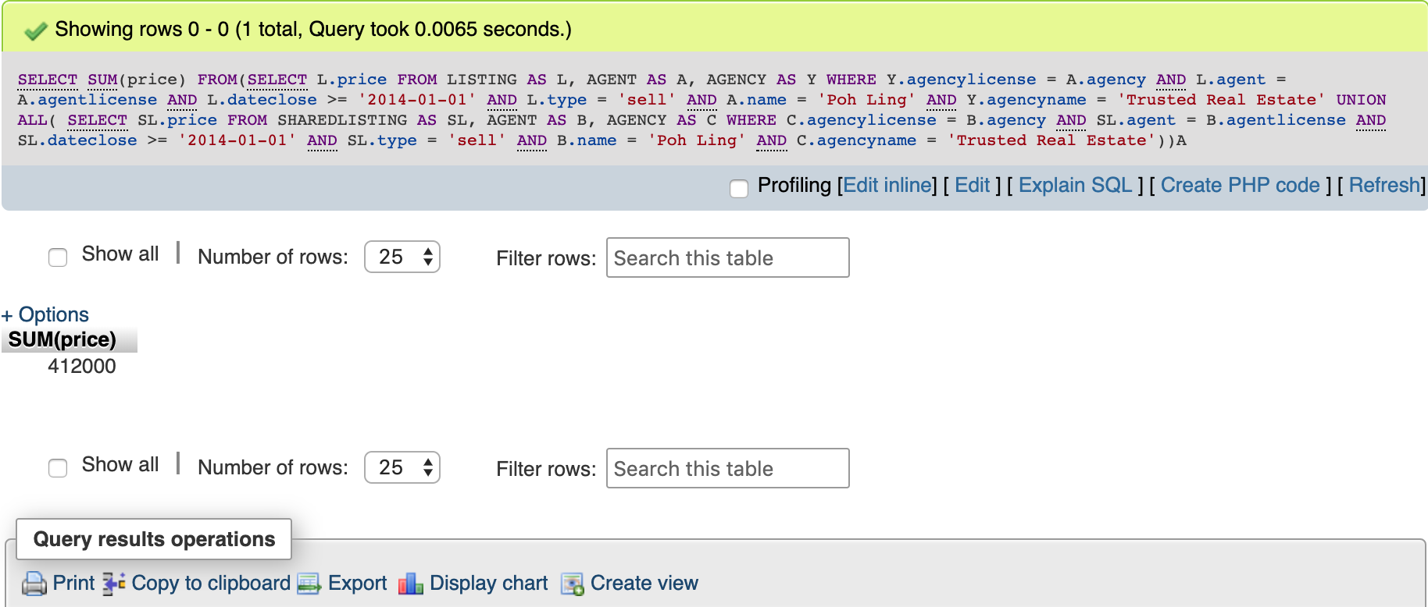

6. Which suburb’s properties have always been sold in less than 4 weeks

SELECT A.suburb

FROM PROPERTY AS A

GROUP BY A.suburb

HAVING A.suburb NOT IN (SELECT B.suburb

FROM PROPERTY AS B, LISTING AS C

WHERE B.pid = C.pid AND (C.type = 'rent' OR DATEDIFF(C.dateclose , C.datelisted) > 28) AND B.suburb NOT IN(

SELECT D.suburb

FROM PROPERTY AS D

GROUP BY D.suburb

HAVING D.suburb NOT IN(

SELECT E.suburb

FROM PROPERTY AS E, SHAREDPROPERTY AS SP, SHAREDLISTING AS SL

WHERE E.pid = SP.pid AND SP.pid = SL.pid AND SP.unitno = SL.unitno AND (SL.type = 'sell' OR DATEDIFF(SL.dateclose , SL.sdatelisted) > 28))))

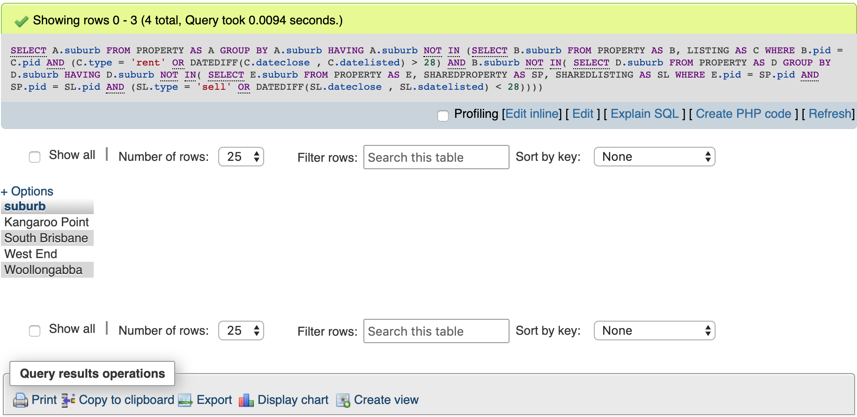

7. What is the average number of car spaces available for houses on Pyrmont Bridge Road

SELECT AVG(carspaces)

FROM PROPERTY

WHERE stname = 'Pyrmont Bridge' AND sttype = 'Road' AND pid NOT IN (

SELECT pid FROM SHAREDPROPERTY)

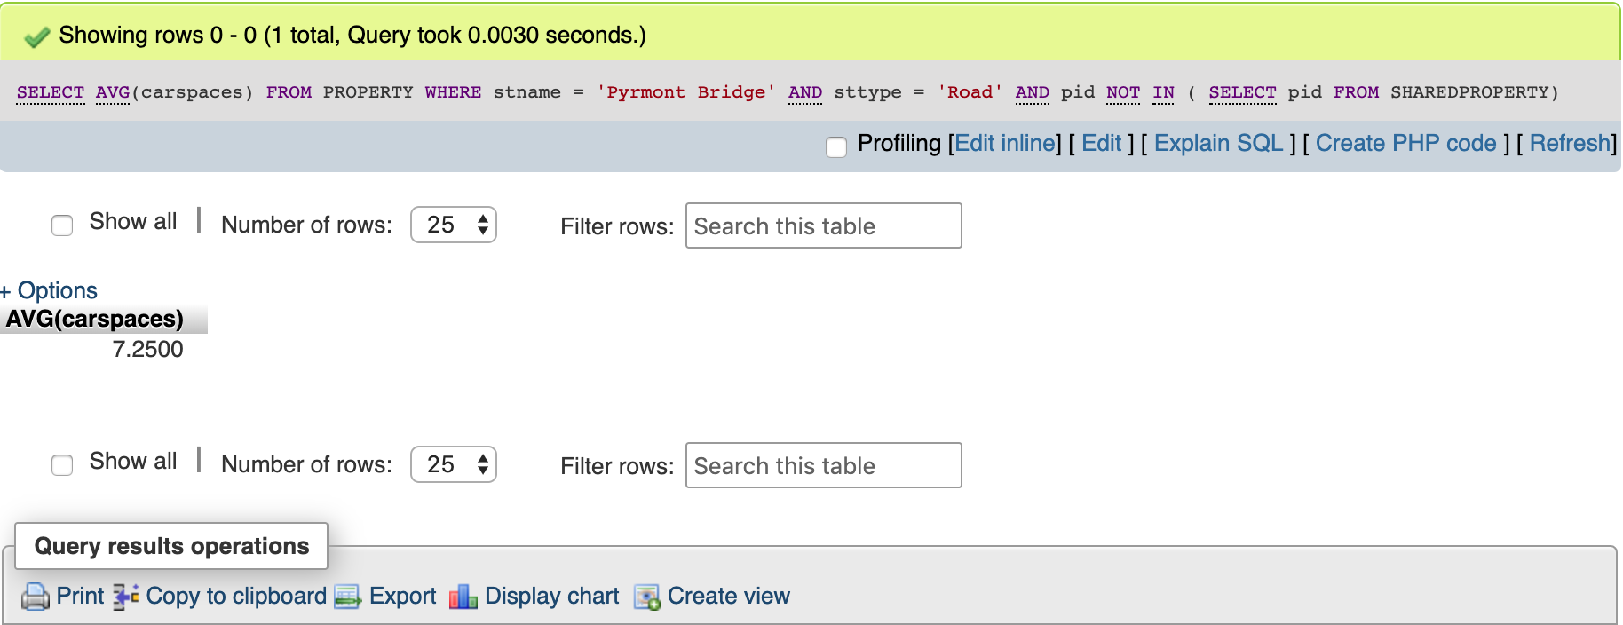

8. Which suburb(s) has had the highest increase in average rent between 2014 and 2016

SELECT P.suburb

FROM (PROPERTY AS P

RIGHT JOIN(

SELECT pid,price

FROM(SELECT pid,price

FROM LISTING

WHERE dateclose LIKE '2014%' AND type = 'rent'

UNION ALL

SELECT pid,price

FROM SHAREDLISTING

WHERE dateclose LIKE '2014%' AND type = 'rent')PE) AS PE

ON P.pid = PE.pid),

PROPERTY AS X RIGHT JOIN(

SELECT pid,price

FROM(SELECT pid,price

FROM LISTING

WHERE dateclose LIKE '2016%' AND type = 'rent'

UNION ALL

SELECT pid,price

FROM SHAREDLISTING

WHERE dateclose LIKE '2016%' AND type = 'rent')APE) AS APE

ON X.pid = APE.pid

GROUP BY P.suburb

ORDER BY (AVG(PE.price) - AVG(APE.price))

DESC LIMIT 1

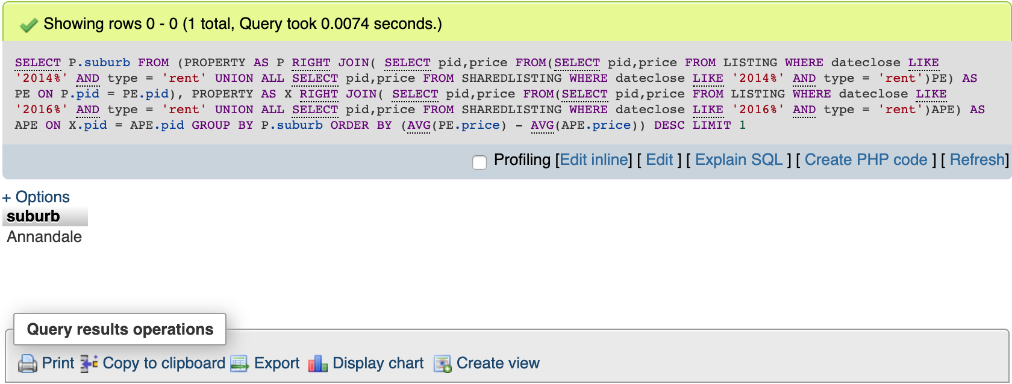

1. List the properties that have been sold by real estate agencies that are located in the same suburb as the property

SELECT pid

FROM(

SELECT P.pid

FROM PROPERTY AS P, LISTING AS L

WHERE P.pid = L.pid AND L.type = 'sell' AND L.pid IN (

SELECT LA.pid

FROM LISTING AS LA, AGENT AS AG

WHERE LA.agent = AG.agentlicense AND AG.agentlicense IN(

SELECT BG.agentlicense

FROM AGENT AS BG, AGENCY AS AY

WHERE BG.agency = AY.agencylicense AND AY.agencylicense IN(

SELECT CY.agencylicense

FROM AGENCY AS CY, BRANCH AS BR

WHERE CY.agencylicense = BR.agency AND BR.brsuburb = P.suburb

)))

UNION ALL(

SELECT PY.pid

FROM PROPERTY AS PY, SHAREDPROPERTY AS SP

WHERE PY.pid = SP.pid AND SP.pid IN(

SELECT SHP.pid

FROM SHAREDPROPERTY AS SHP, SHAREDLISTING AS SL

WHERE SHP.pid = SL.pid AND SHP.unitno = SL.unitno AND SL.type = 'sell' AND SL.pid IN(

SELECT SHL.pid

FROM SHAREDLISTING AS SHL, AGENT AS DT

WHERE SHL.agent = DT.agentlicense AND DT.agentlicense IN(

SELECT ET.agentlicense

FROM AGENT AS ET, AGENCY AS DY

WHERE ET.agency = DY.agencylicense AND DY.agencylicense IN(

SELECT EY.agencylicense

FROM AGENCY AS EY, BRANCH AS CH

WHERE EY.agencylicense = CH.agency AND CH.brsuburb = PY.suburb

))))))Y

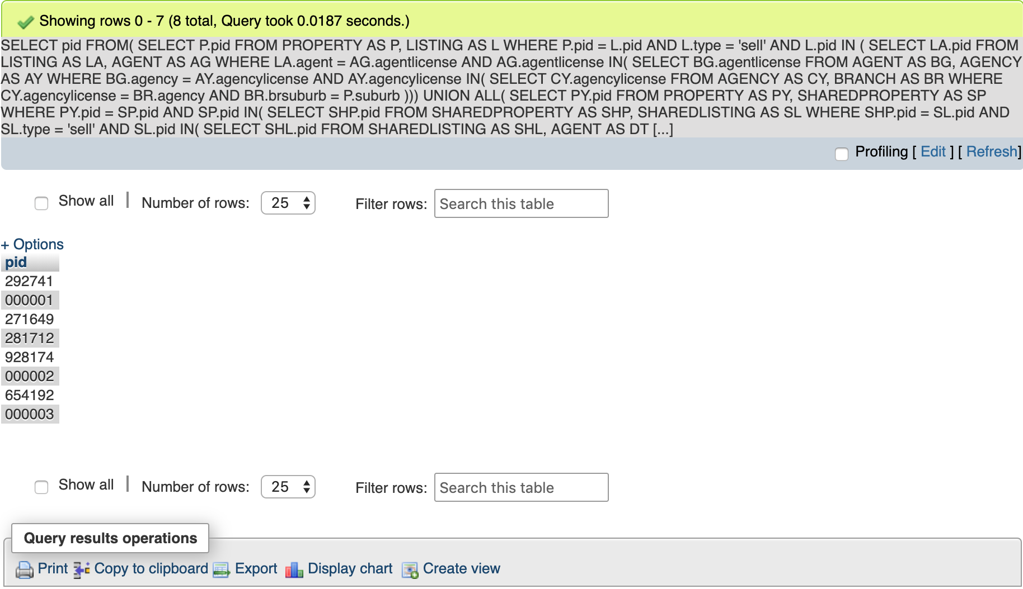

2. Who is the most successful real estate agent in 2018. (Hint: who has sold and rented properties of the greatest value)

SELECT agent

FROM LISTING

WHERE dateclose LIKE '2018%'

GROUP BY agent

HAVING SUM(price) >= ALL(

SELECT SUM(price)

FROM LISTING

WHERE dateclose LIKE '2018%'

GROUP BY agent)

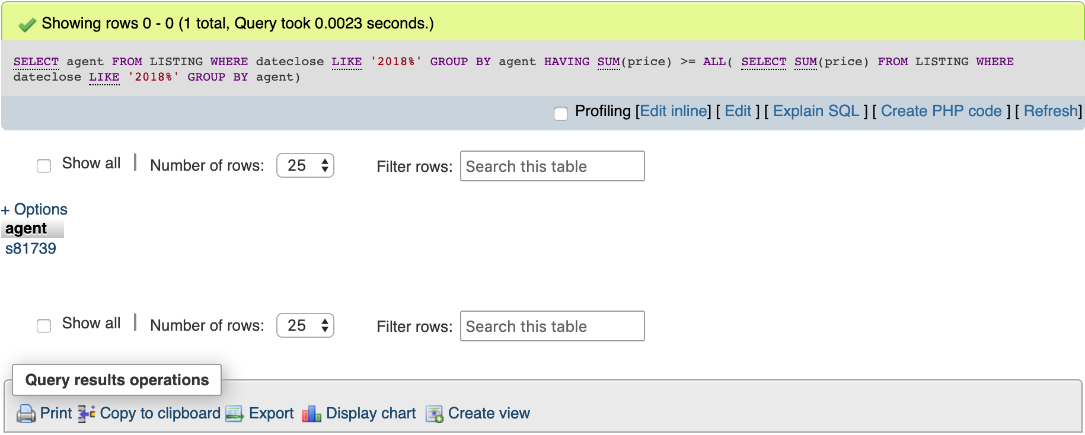

SELECT P.stname, P.sttype

FROM PROPERTY AS P, SHAREDPROPERTY AS SP, SHAREDLISTING AS SL, LISTING AS L

WHERE (P.pid = SP.pid OR P.pid = L.pid) AND SP.pid = SL.pid AND P.suburb = 'Camperdown'

AND (SL.type = 'rent' OR L.type = 'rent')

GROUP BY P.stname, P.sttype

[SELECT](https://infs1200-159b330f.uqcloud.net/phpmyadmin/url.php?url=https://dev.mysql.com/doc/refman/5.5/en/select.html) P.stname FROM PROPERTY AS P WHERE P.stname [IN](https://infs1200-159b330f.uqcloud.net/phpmyadmin/url.php?url=https://dev.mysql.com/doc/refman/5.5/en/comparison-operators.html#function_in)( [SELECT](https://infs1200-159b330f.uqcloud.net/phpmyadmin/url.php?url=https://dev.mysql.com/doc/refman/5.5/en/select.html) AP.stname FROM PROPERTY AS AP, LISTING AS L WHERE L.type = 'rent' [AND](https://infs1200-159b330f.uqcloud.net/phpmyadmin/url.php?url=https://dev.mysql.com/doc/refman/5.5/en/logical-operators.html#operator_and)AP.suburb = 'Camperdown' GROUP BY AP.stname HAVING [AVG](https://infs1200-159b330f.uqcloud.net/phpmyadmin/url.php?url=https://dev.mysql.com/doc/refman/5.5/en/group-by-functions.html#function_avg)(L.price) >= ALL( [SELECT](https://infs1200-159b330f.uqcloud.net/phpmyadmin/url.php?url=https://dev.mysql.com/doc/refman/5.5/en/select.html) AP.stname FROM PROPERTY AS AP, LISTING AS L WHERE L.type ='rent' [AND](https://infs1200-159b330f.uqcloud.net/phpmyadmin/url.php?url=https://dev.mysql.com/doc/refman/5.5/en/logical-operators.html#operator_and) P.suburb = 'Camperdown')) [OR](https://infs1200-159b330f.uqcloud.net/phpmyadmin/url.php?url=https://dev.mysql.com/doc/refman/5.5/en/logical-operators.html#operator_or) P.stname [IN](https://infs1200-159b330f.uqcloud.net/phpmyadmin/url.php?url=https://dev.mysql.com/doc/refman/5.5/en/comparison-operators.html#function_in)( [SELECT](https://infs1200-159b330f.uqcloud.net/phpmyadmin/url.php?url=https://dev.mysql.com/doc/refman/5.5/en/select.html) BP.stname FROM PROPERTY AS BP, SHAREDPROPERTY AS SP, SHAREDLISTING AS SL WHERESL.type = 'rent' [AND](https://infs1200-159b330f.uqcloud.net/phpmyadmin/url.php?url=https://dev.mysql.com/doc/refman/5.5/en/logical-operators.html#operator_and) BP.stname = 'Camperdown' GROUP BY BP.stname HAVING [AVG](https://infs1200-159b330f.uqcloud.net/phpmyadmin/url.php?url=https://dev.mysql.com/doc/refman/5.5/en/group-by-functions.html#function_avg)(SL.price) >= ALL( [SELECT](https://infs1200-159b330f.uqcloud.net/phpmyadmin/url.php?url=https://dev.mysql.com/doc/refman/5.5/en/select.html) BP.stname FROM PROPERTY AS BP,SHAREDPROPERTY AS SP, SHAREDLISTING AS SL WHERE SL.type = 'rent' [AND](https://infs1200-159b330f.uqcloud.net/phpmyadmin/url.php?url=https://dev.mysql.com/doc/refman/5.5/en/logical-operators.html#operator_and) BP.stname = 'Camperdown' GROUP BY BP.stname)) GROUP BY P.stname